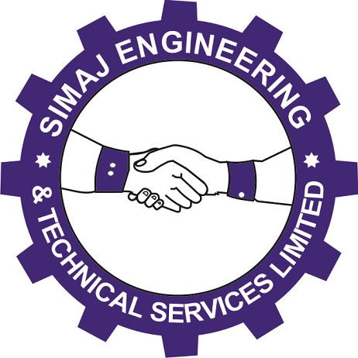
SIMAJ
ENGINEERING AND TECHNICAL SERVICES LIMITED RC1193072
www.simajonline.com
COMPANY PROFILE OF

SIMAJ
ENGINEERING
AND
TECHNICAL SERVICES
LIMITED

Business Address: No. 125/127 Maiduguri Road, Kano, Kano State
Tel: +2347063365325, +2348036731245
Email: simajonline@gmail.com
Website:www.simajonline.com
Company Registration Number: RC1193072

INTRODUCTION

SIMAJ Engineering and Technical Services Limited is an indigenous company, wholly owned and operated by highly qualified and experienced professionals. SIMAJ is a company duly incorporated in Nigeria with registration No. RC1193072.

It is a private company registered om 27th May 2014, with a solid foundation to providing specialized services to all classes of customers/clients including the public and private institutions.
SIMAJ Engineering and Technical Services Limited is made up of a comprehensive team of engineers, medical doctors, scientists, fund managers and other professionals who overtime have proved to be the best in service delivery in terms of speed and quality in the country today. We are driven by an unquenchable passion for excellence; we offer our services in record time without compromising quality and standard.

As an import and export Company, Our overseas partners and manufacturers in Europe, America and Asia are always at our service. We supply, install and service engineering equipment, technical equipment and material, science and laboratory equipment, hospital equipment etc. we also undertake construction, site and project management to mention just a few.

VISION STATEMENT

Our vision is to provide world class services in computing, medical and analytical equipment in Nigeria

MISSION STATEMENT

To provide excellent services in supply and training of computing, medical and analytical equipment in Nigeria by deploying state of art equipment and providing reliable technical backup using qualified and experienced professionals

FOCUS

- CONSULTANCY SERVICES
- EDUCATION AND TRAINING
- EQUIPMENT AND SUPPLY
- ICT SOLUTION
- LABORATORY TESTING SERVICES
- ENGINEERING EQUIPMENT AND MATERIALS
- GENERAL CONTRACTOR

PRODUCTS AND SERVICES

- ENGINEERING EQUIPMENT/MATERIALS
- TECHNICAL MATERIALS/EQUIPMENT
- SCIENCE/LABORATORY EQUIPMENT
- LABORATORY CHEMICALS
- ICT SERVICES
- LABORATORY FURNITURE/FITTINGS
- EQUIPMENT TESTING MATERIALS
- AUDIO/VISUAL EQUIPMENT
- HOSPITAL EQUIPMENT
- CONSULTANCY SERVICES
- ENVIRONMENTAL/SITE PREPARATIONS
- TECHNICAL SUPPLIES AND MAINTENANCE
- PROJECT PLANNING AND MONITORING
- PROJECT MANAGEMENT
- INSTALLATIONS AND TRAINING
- CONSTRUCTION
- GENERAL CONTRACTOR

BOARD OF DIRECTORS

Prof. Baba Elyakubu Jibril (PhD, Chem. Engineering) - Chairman
Alhaji Muhammad Bello Abubakar (MBA) - Director
Prof. Ibrahim Muhammad Inuwa (PhD, Medicine) - Director
Prof. Sahalu Balarebe Junaid (PhD, Comp. Sci.) - Director
Dr. Abdulazeez Yusuf Atta (PhD, Chem. Engineering) - Director

